Week 15

Question 1:
Given an array of integers, reverse the given array in place using an index and loop rather
than a built-in function.
Example
arr = [1, 3, 2, 4, 5]
Return the array [5, 4, 2, 3, 1] which is the reverse of the input array.
Function Description
Complete the function reverseArray in the editor below.
reverseArray has the following parameter(s):
int arr[n]: an array of integers
Return
int[n]: the array in reverse order
Constraints
1 ≤ n ≤ 100
0 < arr[i] ≤ 100
Input Format For Custom Testing
The first line contains an integer, n, the number of elements in arr.
Each line i of the n subsequent lines (where 0 ≤ i < n) contains an integer, arr[i].
Sample Input For Custom Testing
4
17
10
21
45
Sample Output
45
21
10
17
4
Explanation
The input array is [4, 17, 10, 21, 45], so the reverse of the input array is [45, 21, 10, 17, 4].

Program:
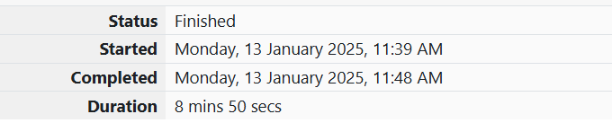
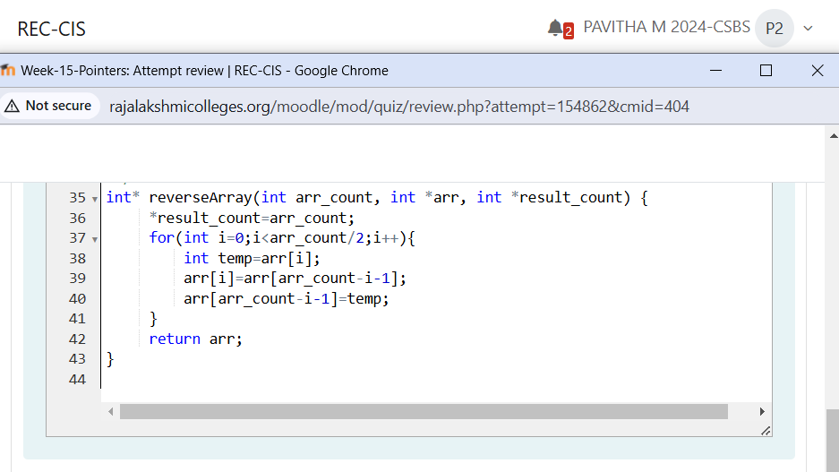
Output:
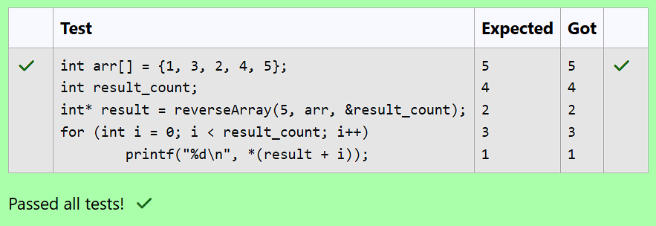

Question 2:
An automated cutting machine is used to cut rods into segments. The cutting machine can
only hold a rod of minLength or more, and it can only make one cut at a time. Given the
array lengths [] representing the desired lengths of each segment, determine if it is
possible to make the necessary cuts using this machine. The rod is marked into lengths
already, in the order given.
Example
n = 3
lengths = [4, 3, 2]
minLength = 7
The rod is initially sum(lengths) = 4 + 3 + 2 = 9 units long. First cut off the segment of length
4 + 3 = 7 leaving a rod 9 - 7 = 2. Then check that the length 7 rod can be cut into segments
of lengths 4 and 3. Since 7 is greater than or equal to minLength = 7, the final cut can be
made. Return "Possible".
Example
n = 3
lengths = [4, 2, 3]
minLength = 7
The rod is initially sum(lengths) = 4 + 2 + 3 = 9 units long. In this case, the initial cut can
be of length 4 or 4 + 2 = 6. Regardless of the length of the first cut, the remaining piece
will be shorter than minLength. Because n - 1 = 2 cuts cannot be made, the answer is
"Impossible".
Function Description
Complete the function cutThemAll in the editor below.
cutThemAll has the following parameter(s):
int lengths[n]: the lengths of the segments, in order
int minLength: the minimum length the machine can accept
Returns
string: "Possible" if all n-1 cuts can be made. Otherwise, return the string
"Impossible".
Constraints
• 2 ≤ n ≤ 105
• 1 ≤ t ≤ 109
• 1 ≤ lengths[i] ≤ 109
• The sum of the elements of lengths equals the uncut rod length.
Input Format For Custom Testing
The first line contains an integer, n, the number of elements in lengths.
Each line i of the n subsequent lines (where 0 ≤ i < n) contains an integer, lengths[i].
The next line contains an integer, minLength, the minimum length accepted by the
machine.
Sample Input For Custom Testing
STDIN Function
----- --------
4 → lengths[] size n = 4
3 → lengths[] = [3, 5, 4, 3]
5
4
3
9 → minLength= 9

Sample Output:
Possible
Explanation:
The uncut rod is 3 + 5 + 4 + 3 = 15 units long. Cut the rod into lengths of 3 + 5 + 4
= 12 and 3.
Then cut the 12-unit piece into lengths 3 and 5 + 4 = 9.
The remaining segment is 5 + 4 = 9 units and that is long enough to make the final
cut.

Program:

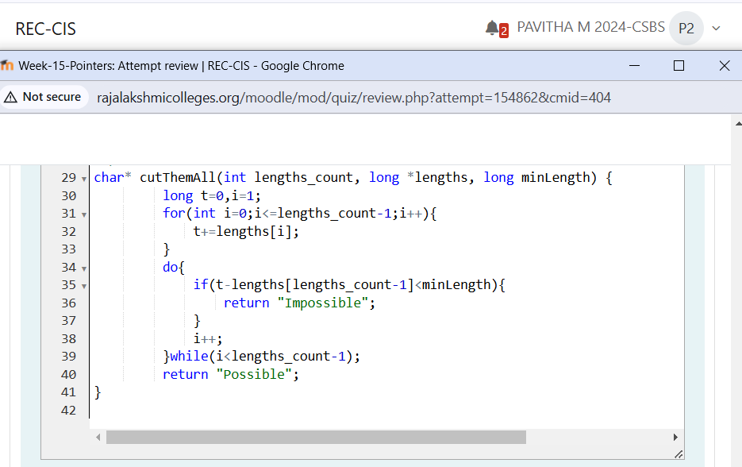
Output:
